Quiz Evalution & Analytics App

Team Members :
KHV . Sai Eswar--2500030318
R.Nikhil Manikanta—2500030163
Venkata Hathiek.P—2500030093

Abstract :
- This project builds a Quiz Evaluation & Analytics App that automatically grades MCQ quizzes.
- It compares student responses with correct answers and calculates scores with marking and penalty rules.
- The system analyzes question difficulty using correctness percentages and statistical measures.
- It applies OOP concepts like abstract classes, interfaces, and design patterns such as Template Method and Strategy.
- Student scores are stored using Maps, errors are handled with custom exceptions, and the final output is a detailed report.csv.

Problem Statement :
- Educational institutions and online learning platforms frequently conduct quizzes to assess learners understanding.
- However, the manual evaluation of quizzes is time-consuming, prone to human error, and does not provide deeper insights into student performance or the effectiveness of questions.
- Existing basic evaluation methods usually focus only on total scores and fail to analyze question difficulty, accuracy rates, and overall trends in learner responses.

Objectives :
- Automate quiz evaluation
Automatically check student responses with correct answers to avoid manual correction.
- Provide accurate scoring and results
Calculate correct, wrong answers, total score, and percentage without errors.
- Analyze question difficulty
Identify easy and hard questions based on student performance.
- Generate detailed performance reports
Create a report.csv file showing marks, percentage, and qualification status.
- Save time and improve learning insights
Reduce teacher workload and help students understand and improve their performance.

Design Part :
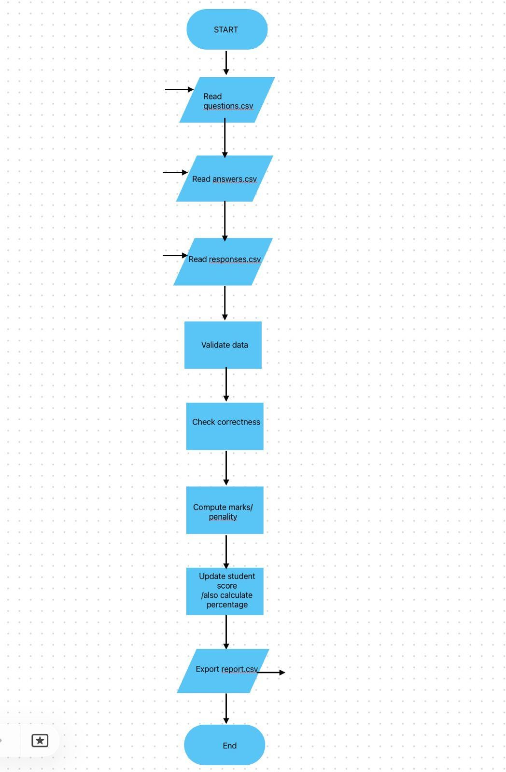

Implementation :
In Project.main, a Scanner is used to read from the console the paths of three CSV files: questions, answers, and responses. For each path, corresponding file-wrapper objects are created: InputFile for questions, AnswerFile for correct answers, and ResponseFile for student responses.​
The program then checks if all three files exist; if any is missing, it prints “One or more files not found!”, closes the scanner, and terminates without processing. If they are all valid, it calls Evaluator.compare(aFile.getAnswers(), rFile.getResponses()) to compute how many answers are correct and wrong, receiving an int[] where index 0 is correct and index 1 is wrong.​
Next, a Scoring object is created with new Scoring(1, 0), which means 1 mark for each correct answer and 0 for each wrong one. The program calls scoring.calculateScore(aFile.getAnswers(), rFile.getResponses()) to compute the total score by iterating over all question numbers and adding correctMark if the trimmed, case-insensitive answer matches, otherwise adding wrongMark.​
The difficulty of each question is then computed by calling DifficultyAnalyzer. analyzeDifficulty(aFile.getAnswers(), rFile.getResponses()), which returns a List of difficulty indicators corresponding to the questions. Finally, the program asks the user for an output CSV filename, prints a confirmation that the file is created, and calls ResultWriter.writeResult(outputFile, aFile.getAnswers(), rFile.getResponses(), evaluationResult, totalScore, difficultyResult) to write all per-question and summary data into the result file.​
Core logic classes
The Evaluator class provides a static method compare(Map answers, Map responses) that iterates over all question numbers in the answers map. For each key, if answers.get(qNo).equals(responses.get(qNo)) is true, it increments the correct counter; otherwise, it increments wrong, and finally returns new int[]{correct, wrong}.​
The Scoring class stores correctMark and wrongMark as instance fields set via the constructor Scoring(int correctMark, int wrongMark). In calculateScore(Map answers, Map responses), it initializes score to 0, then for each question number checks ans and res, applies trim() and equalsIgnoreCase, and increases score by correctMark for a match or by wrongMark otherwise, returning the final score.​
Together, these implementations provide a complete pipeline: reading file paths, validating inputs, comparing answers and responses, scoring, analyzing difficulty, and writing a consolidated CSV report.

Sample Input & Output :
Inputs :
Question.csv
General Knowledge (GK)
What is the capital of India?
a Mumbai
b Kolkata
c New Delhi
d Chennai
Which planet is known as the Red Planet?
a Venus
b Jupiter
c Saturn
d Mars …………
………………………….so on
-------- -------- ------------ -------- -------- ------ ---------
Answer.csv
c
d
c
d
c
d
d
c
c
c
Response.csv
c
d
c
d
c
d
d
c
c
c
-------- ----------- ---------- ------------
Output :
--- Evaluation ---
Correct : 6
Wrong : 4
Total Score : 6
--- Question Difficulty ---
Q.No Status Difficulty
1 Correct Easy
2 Wrong Hard
3 Correct Easy
4 Correct Easy
5 Wrong Hard
6 Wrong Hard
7 Correct Easy
8 Correct Easy
9 Correct Easy
10 Wrong Hard

Testing outputs:
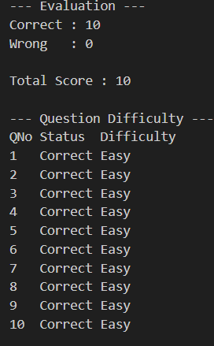
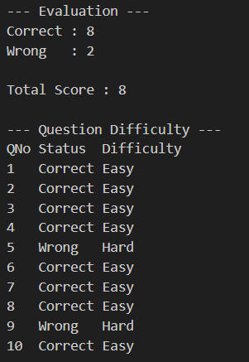

Conclusion :
This project successfully achieves its goal of automating the evaluation of student responses using CSV-based input and output. By separating concerns into dedicated classes for input handling, evaluation, scoring, difficulty analysis, and result writing, the design remains modular, readable, and easy to extend.​

The system reduces manual effort in checking objective answers by accurately comparing correct answers with student responses and computing total scores with a configurable marking scheme. The inclusion of difficulty analysis further adds value by helping educators identify which questions are easy, moderate, or difficult based on performance data.​

Overall, the project demonstrates practical use of core Java concepts such as file handling, collections, and console interaction to solve a real-world educational problem. With minor enhancements like a graphical interface, support for multiple students, and richer statistics, this system can evolve into a more comprehensive assessment tool.\

